hw #18/Dada/Surrealism

Dada:
“I am interested in ideas, not merely visual products.” -Marcel Duchamp

Surrealism:
“One day it will have to be officially admitted that what we have christened reality and this is an even greater illusion than the world of dreams.” -Salvador Dali

The Photographs below were taken during my visit to the Salvador Dali Museum where Dali and his wife resided. This is the famous cove seen in his painting, The Persistence of Memory.

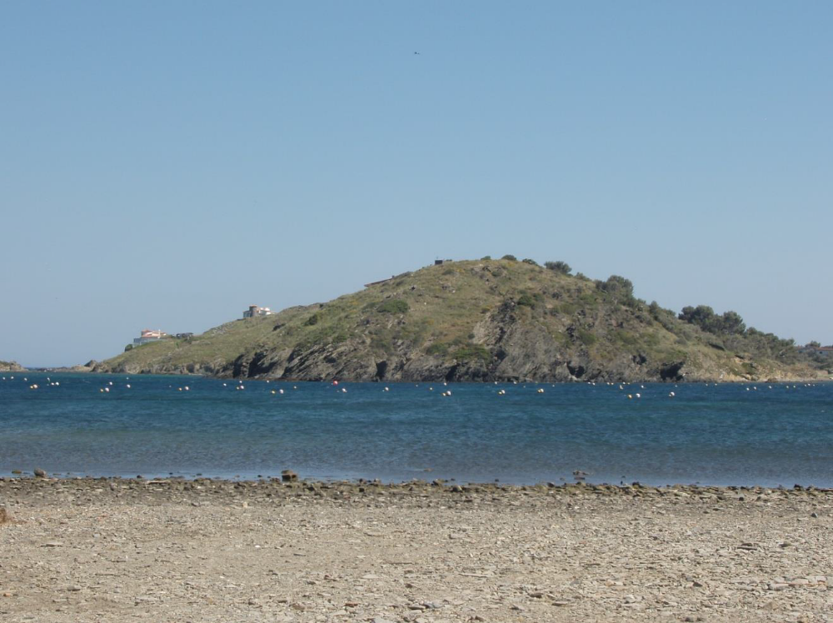

This photograph is of the famous Dali house and museum. It looks out to the cove in the photograph above.

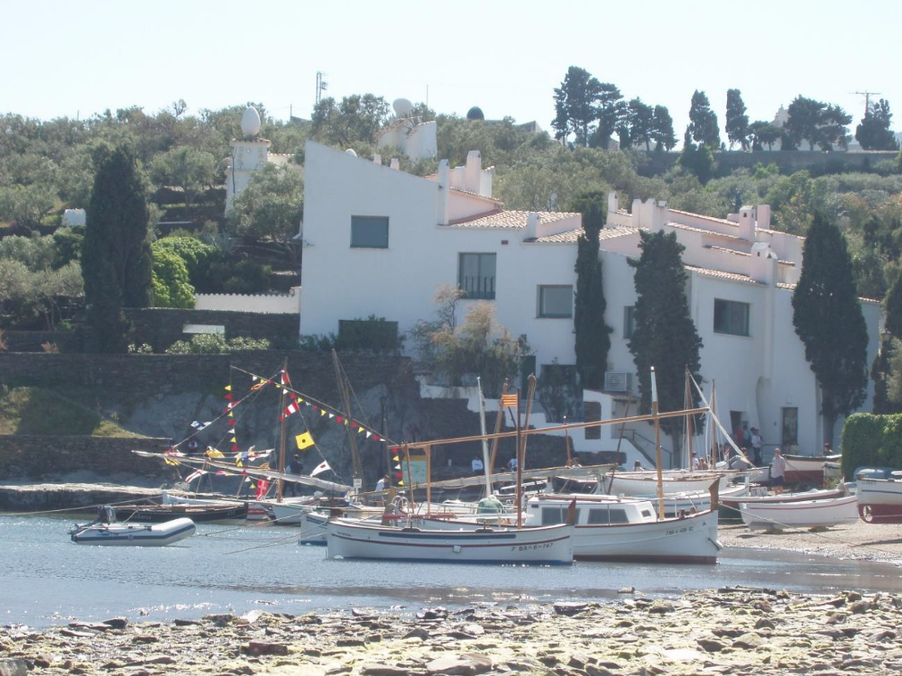

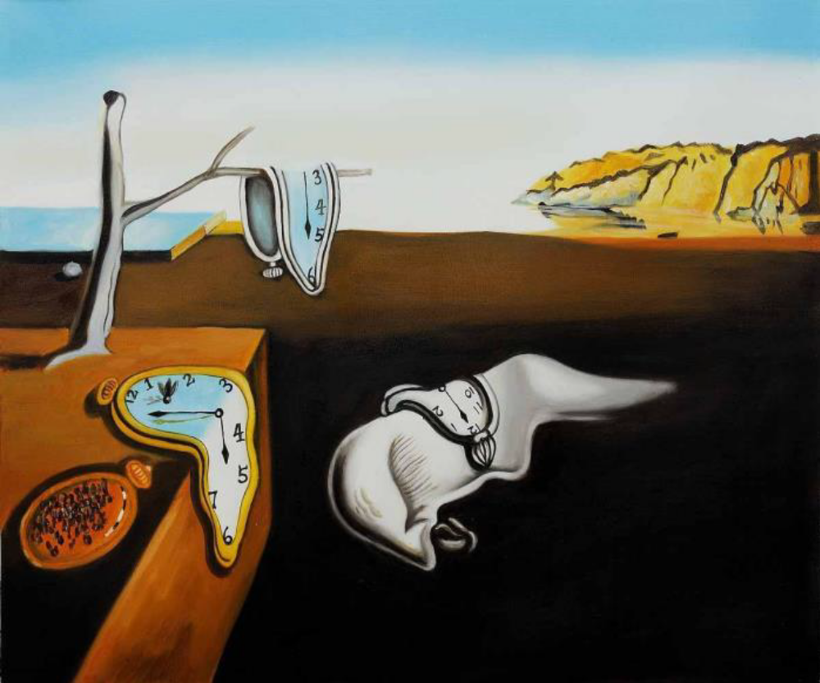
The Persistence of Memory

“If the dream is a translation of waking life, waking life is also a translation of the dream.” -Rene Magritte

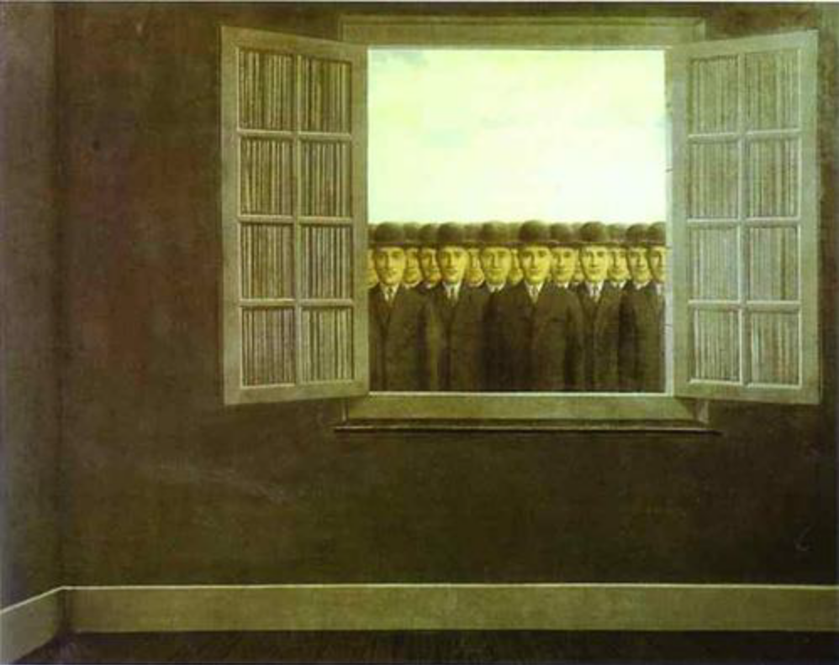
Grape Harvest

Assignment:
Study the two paintings above, The Persistence of Memory by the Spanish Surrealist painter, Salvador Dali and Grape Harvest by the French Surrealist painter, Rene Magritte. How is each a reflection of the times in which they were painted, the theories of the subconscious mind of Dr. Sigmund Freud and the Theory of Relativity by Dr. Albert Einstein? Each artist has his own style and inventions in depicting Surrealism, but how did each artist create it in his painting? Define Surrealism then describe each painting in view of the questions above. (One page)

